**Multimedia Communication Project**

**Members: Role**

**Maha Multimedia Specialist**

**Ibraheem Project Manager & Voice over Artist**

**Asim Subject Matter Specialist**

**Nimra Script Writer**

**Aqib Graphic Designer & Video Editor**

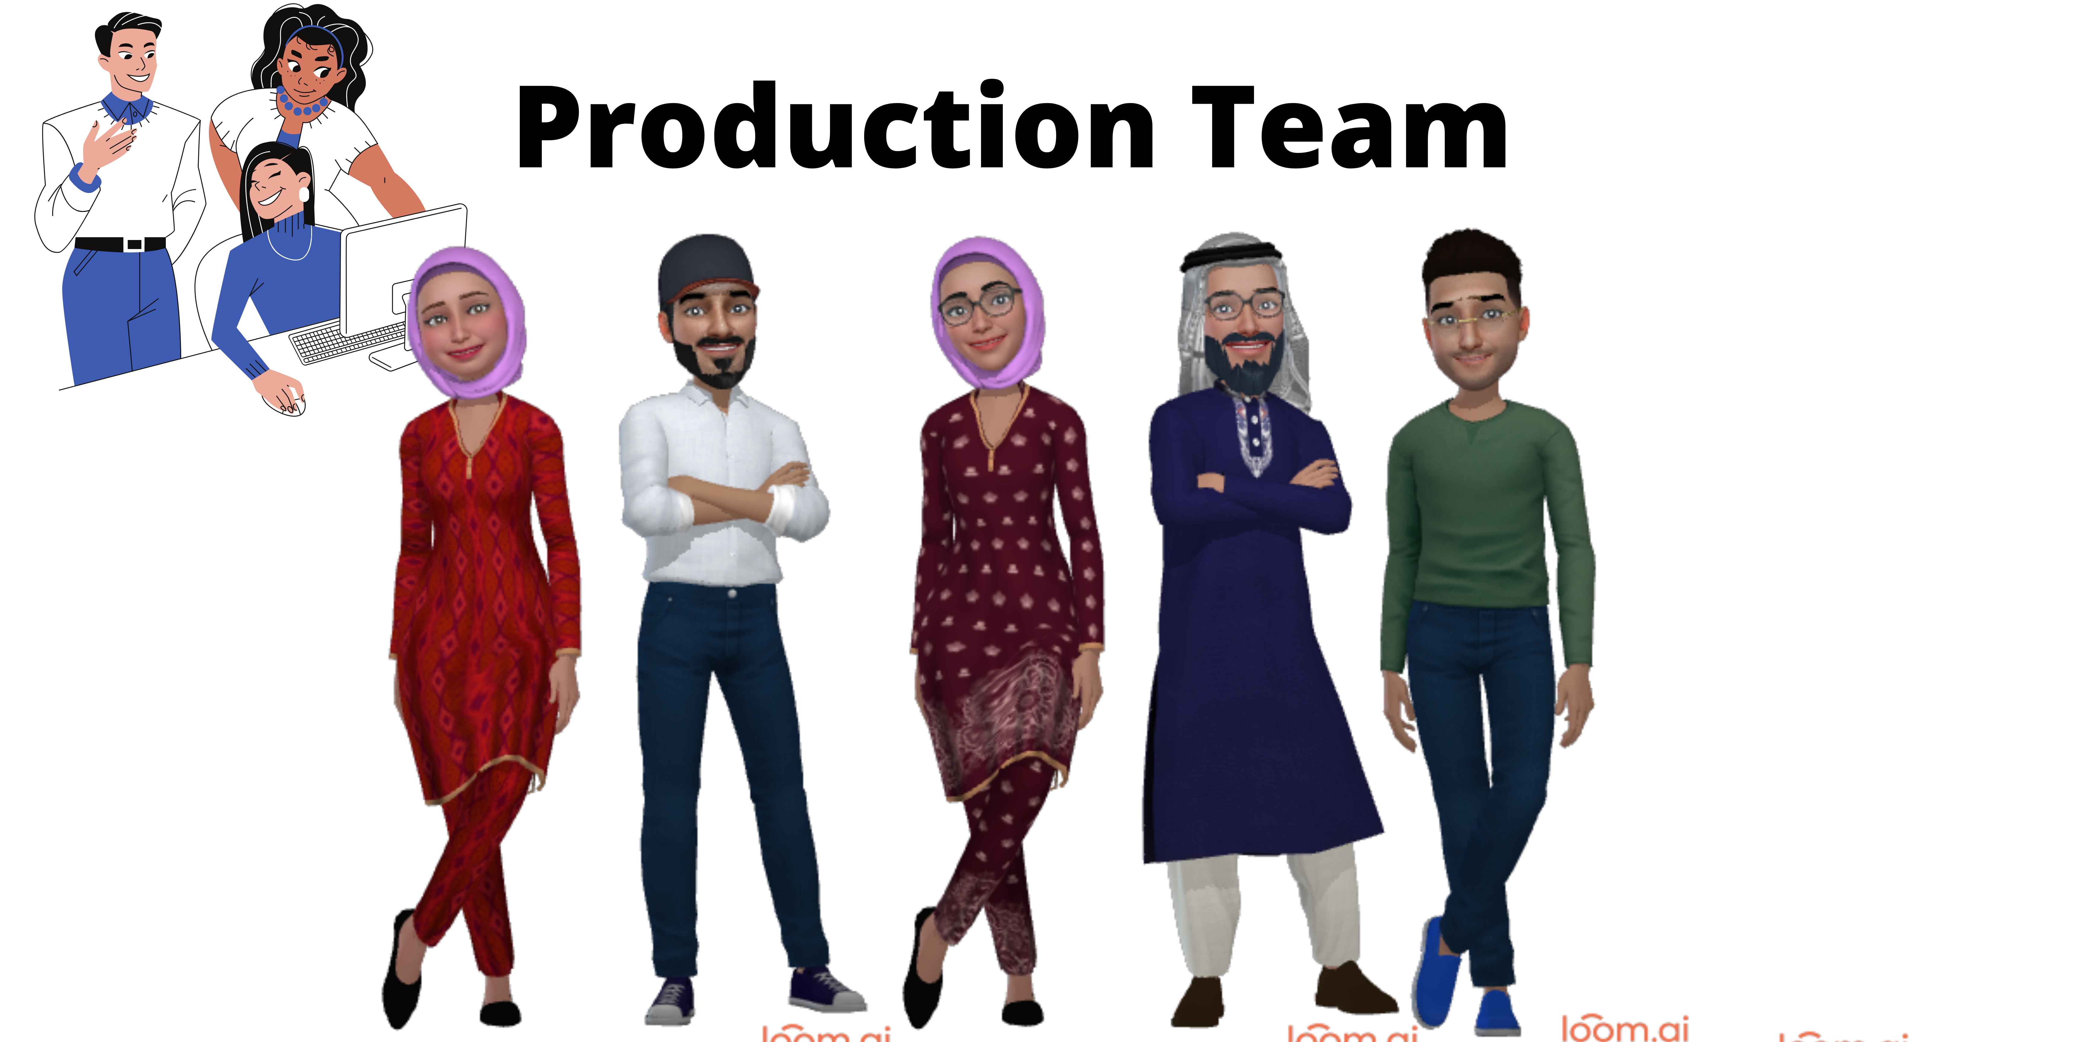

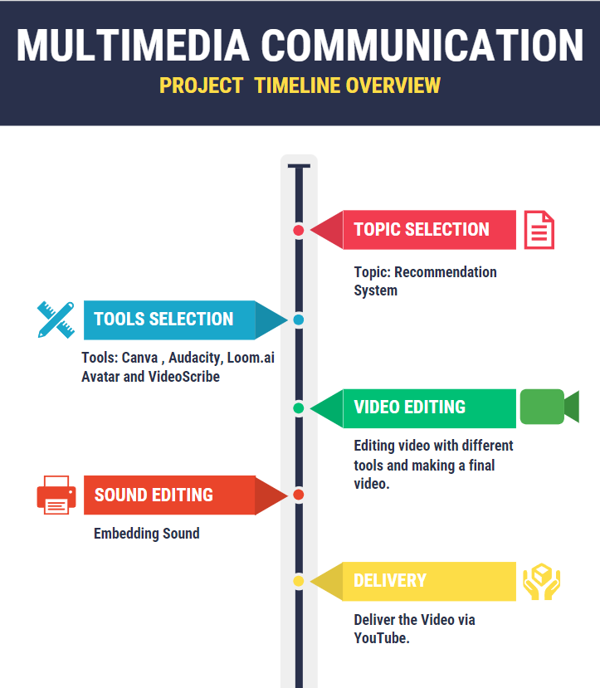

**Day to Day Project Timeline**

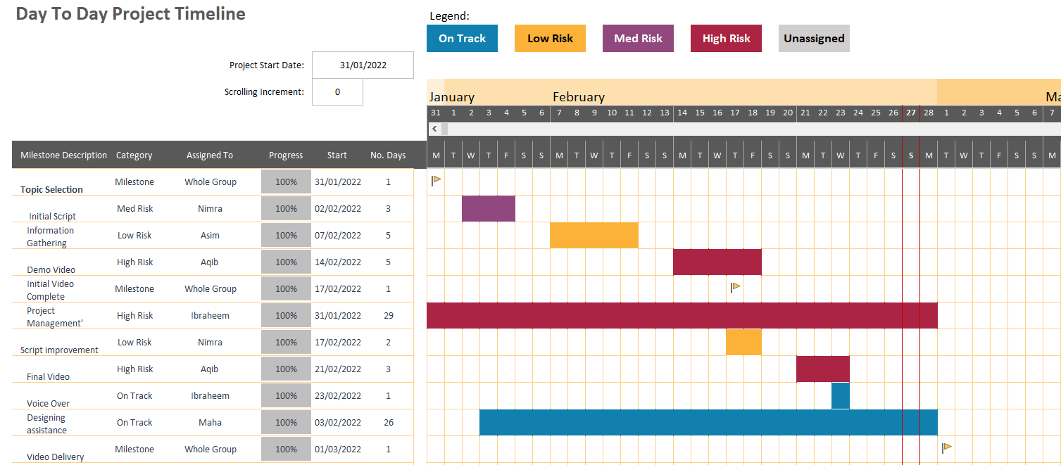

|  |  |  |  |
| --- | --- | --- | --- |
| Meeting No | Agenda | Date | Page # |
| 01 | **Initial Script** | **31 Jan** | **04** |
|  |  |  |  |
| 02 | **Understanding the Script and apply the domain knowledge** | **4 Feb** | **05** |
|  |  |  |  |
| 03 | **Discussion and reviews on Demo video of the selected topic.** | **14 Feb** | **06** |
|  |  |  |  |
| 04 | **Final video** | **23 Feb** | **07** |
|  |  |  |  |
| 05 | **Voice Over** | **28 Feb** | **08** |

Meeting |01

## Meeting date | time **31 Jan 2022 | 10:00 A.M** | Meeting location **Software Department Lab 4**

|  |  |  |  |  |  |  |  |  |  |  |  |
| --- | --- | --- | --- | --- | --- | --- | --- | --- | --- | --- | --- |
| |  |  | | --- | --- | | Meeting called by | Ibraheem | | Type of meeting | Informal | | Facilitator | Ibraheem | | Note taker | Nimra | | Timekeeper | Ibraheem | | **Attendees**  Maha  Asim  Aqib  Nimra |

# Agenda topics

## Time allotted | **15 mins** | Agenda topic Topic Selection | Presenter **All Group Members**

**Discussion on Topic Selection.**

|  |  |  |
| --- | --- | --- |
| Action items | Person responsible | Deadline |
| Finalizing the Topic | All Group Members | **31 Jan 2022** |
|  |  |  |

Getting input from each group member for topic suggestion

**Member : Suggested Topic**

Ibraheem : Sounds , ML

Aqib : Usage of Social Media

Asim : 11 Dimension

Maha : ML

Nimra : Recommended Systems

**Meeting conclusion :**

Selecting Recommended System topic among other topics.

Meeting |02

## Meeting date | time **4 Feb 2022 | 10:00 A.M** | Meeting location **Software Department Seminar Library**

|  |  |  |  |  |  |  |  |  |  |  |  |
| --- | --- | --- | --- | --- | --- | --- | --- | --- | --- | --- | --- |
| |  |  | | --- | --- | | Meeting called by | Ibraheem | | Type of meeting | Formal | | Facilitator | Ibraheem | | Note taker | Nimra | | Timekeeper | Ibraheem | | Attendees  Maha  Asim  Aqib  Nimra |

# Agenda topics

## Time allotted | **20 mins** | Agenda topic **Understanding the Script and apply the domain knowledge** | Presenter **Nimra**

**Initial script.**

|  |  |  |
| --- | --- | --- |
| Action items | Person responsible | Deadline |
| Script Presentation | Nimra | **7 Feb 2022** |
|  |  |  |

Presenting script , framing the scenes and finalizing the characters with dialogs.

**Meeting Conclusion :**

Taking suggestions and Improving the initial script with consent of each group member.

Meeting |03

## Meeting date | time **14 Feb 2022 | 10:00 A.M** | Meeting location **Software Department classroom # 2**

|  |  |  |  |  |  |  |  |  |  |  |  |
| --- | --- | --- | --- | --- | --- | --- | --- | --- | --- | --- | --- |
| |  |  | | --- | --- | | Meeting called by | Ibraheem | | Type of meeting | Formal | | Facilitator | Ibraheem | | Note taker | Nimra | | Timekeeper | Ibraheem | | Attendees  Maha  Asim  Aqib  Nimra |

# Agenda topics

## Time allotted | **15 mins** | Agenda topic **Demo Video** | Presenter **Aqib**

**Discussion and reviews on Demo video of the selected topic.**

|  |  |  |
| --- | --- | --- |
| Action items | Person responsible | Deadline |
| Checking and review on demo video | All Group Members | **21 Feb 2022** |
|  |  |  |

Getting input from each group member about the demo video.

**Meeting conclusion:**

Each group member watches the video and gives their opinions. Needs improvement in character selection.

Meeting |04

## Meeting date | time **21 Feb 2022 | 10:00 A.M** | Meeting location **Software department classroom #2**

|  |  |  |  |  |  |  |  |  |  |  |  |
| --- | --- | --- | --- | --- | --- | --- | --- | --- | --- | --- | --- |
| |  |  | | --- | --- | | Meeting called by | Ibraheem | | Type of meeting | Informal | | Facilitator | Ibraheem | | Note taker | Nimra | | Timekeeper | Ibraheem | | Attendees  Maha  Asim  Aqib  Nimra |

# Agenda topics

## Time allotted | **15 mins** | Agenda topic **Final video** | Presenter Aqib

**Discussion on final video of the selected topic.**

|  |  |  |
| --- | --- | --- |
| Action items | Person responsible | Deadline |
| Aqib taking suggestion about the final video and showing the initial video he has made. | Aqib Ali | **23 Feb 2022** |
|  |  |  |

showing the final video to all group members.

**Meeting conclusion :**

Every one watched the final video and group leader decided the date of final video submission.

Meeting |05

## Meeting date | time **23 Feb 2022 | 10:00 A.M** | Meeting location **Software department Lab 2**

|  |  |  |  |  |  |  |  |  |  |  |  |
| --- | --- | --- | --- | --- | --- | --- | --- | --- | --- | --- | --- |
| |  |  | | --- | --- | | Meeting called by | Ibraheem | | Type of meeting | Informal | | Facilitator | Ibraheem | | Note taker | Nimra | | Timekeeper | Ibraheem | | Attendees  Maha  Asim  Aqib  Nimra |

# Agenda topics

## Time allotted | **15 mins** | Agenda topic **Voice over on video** | Presenter **Ibraheem**

Voice Over

|  |  |  |
| --- | --- | --- |
| Action items | Person responsible | Deadline |
| Ibraheem gives voice over suggestions on the video and voice-overon the video. |  | **28 Feb 2022** |
|  |  |  |

Voice over.

**Meeting conclusion :**

Everyone decided on the final voice-over task and project is completed this was the last meeting.